
Company
Logotype

Cone Beam Computed Tomography- Report



Porur Dental X-rays & CBCT

Patient Name : Mr. Ramachandran | Date of Report : 05.11.2024
Age/ Gender : 48 years/ Male | Region of Interest : CBCT Full Skull
Referring doctor: Dr. Kiruthika Asokan | Indication : Implant assessment
Clinical Notes: Nil
PATIENT INFORMATION

CBCT- Full Skull provided
CBCT – IMAGE DETAILS

RADIOGRAPHIC INTERPRETATION

- Completely edentulous maxillary and mandibular alveolar ridges evident.
- The alveolar ridge in relation to the maxillary and mandibular arch is present with degenerative changes of bone leading to reduced bone height and width.
- The alveolar bone in relation to 21 and 22 region appears to be discontinuous.
- The right maxillary sinus is present with mucosal thickening in relation to the medial wall floor and lateral sinus wall.

IMPLANT ASSESSMENT

 | 11 region | 12 region | 13 region | 14 region | 21 region | 22 region | 23 region | 24 region
Sub-Crestal | 3.2 | 2.6 | 3.7 | 3.6 | 3.1 | 3.8 | 4.4 | 2.5
Mid- Crestal | 4 | 2.1 | 4 | - | 3.7 | 3.3 | 3.6 | -
Distance between the alveolar ridge and Floor of the Nasal cavity (in mm) | 14.6 | 13.2 | 14.1 | 7.4 | 15 | 10 | 9.9 | 10.9

 | 15 region | 16 region | 17 region | 25 region | 26 region | 27 region
Sub-Crestal (in mm) | - | - | - | 2.6 | - | -
Mid- Crestal (in mm) | - | - | - | - | - | -
Distance between the alveolar ridge and floor of the maxillary sinus (in mm) | 2.6 | 2 | 1.5 | 2.8 | 0.3 | 0.6

 | 31 region | 32 region | 33 region | 34 region
Sub-Crestal (in mm) | 5 | 5 | 5.8 | 5.8
Mid- Crestal (in mm) | 5.5 | 6.1 | 5.8 | 6.7
Distance between alveolar ridge and the inferior border of mandible (in mm) | 18.5 | 18.1 | 16.4 | 17.2

 | 41 region | 42 region | 43 region | 44 region
Sub-Crestal (in mm) | 5.4 | 4.1 | 5 | 5.5
Mid- Crestal (in mm) | 5.4 | 5.1 | 5.8 | 6.8
Distance between alveolar ridge and the inferior border of mandible (in mm) | 18.3 | 18.6 | 17.7 | 18.1
 | 45 region | 46 region | 47 region
Sub-Crestal (in mm) | 5.5 | 7 | 8.1
Mid- Crestal (in mm) | 7 | 9.6 | 9.2
Distance between alveolar ridge and the inferior alveolar nerve canal (in mm) | 8.7 | 8.9 | 10
Distance between alveolar ridge and the inferior border of mandible (in mm) | 19.4 | 18.2 | 19.9

 | 35 region | 36 region | 37 region
Sub-Crestal (in mm) | 5.5 | 9.9 | 9.6
Mid- Crestal (in mm) | 6.4 | 8.4 | 9.8
Distance between alveolar ridge and the inferior alveolar nerve canal (in mm) | 9.3 | 4 | 5.5
Distance between alveolar ridge and the inferior border of mandible (in mm) | 20.2 | 13.4 | 16.1

RADIOGRAPHIC IMPRESSION

- Completely edentulous maxillary and mandibular arch.
- Right maxillary sinusitis.

Kindly correlate with clinical findings


IMAGES FOR REFERENCE

RECONSTRUCTED PANORAMIC VIEW

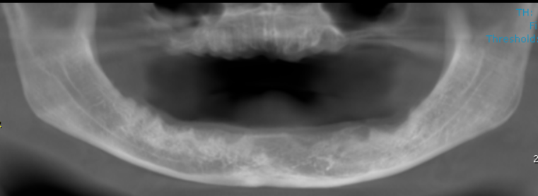

3-DIMENSIONAL VIEW
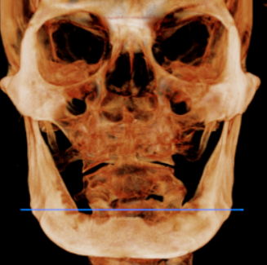

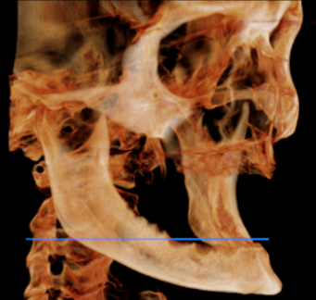
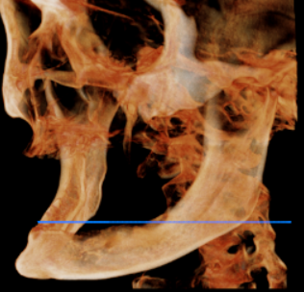

CROSS SECTIONAL VIEW

11 region | 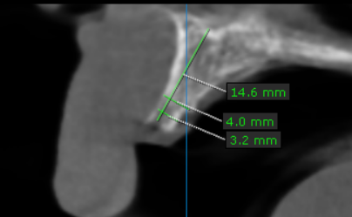
12 region | 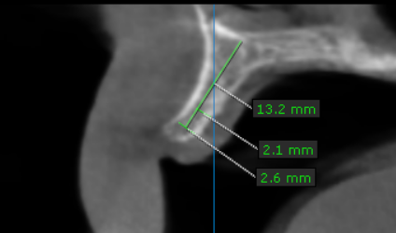
13 region | 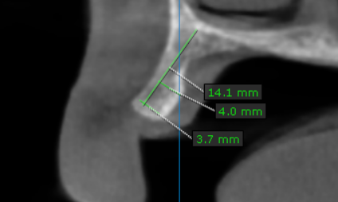
14 region | 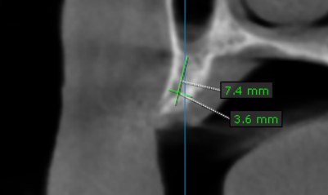
15 region | 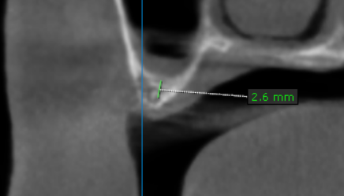
16 region | 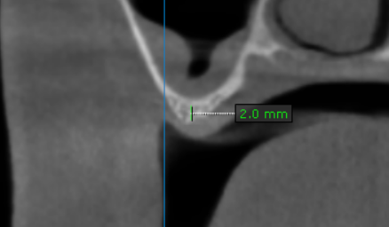
17 region | 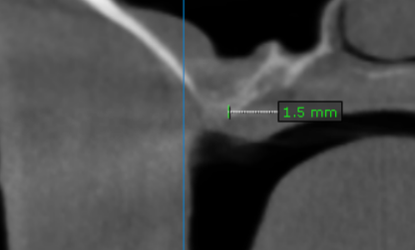
21 region | 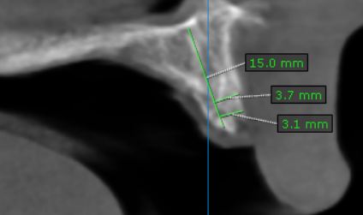
22 region | 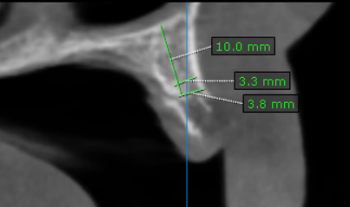
23 region | 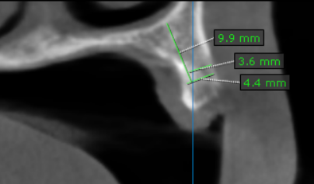
24 region | 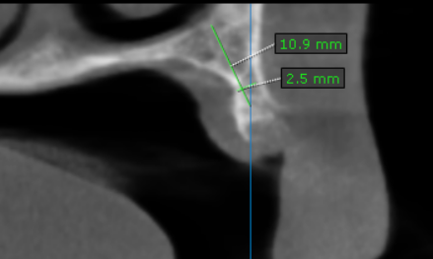
25 region | 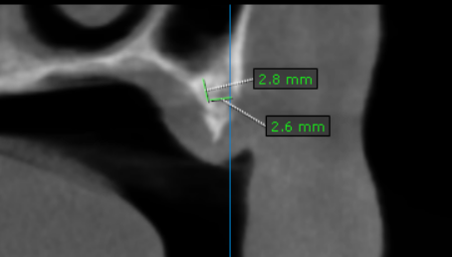
26 region | 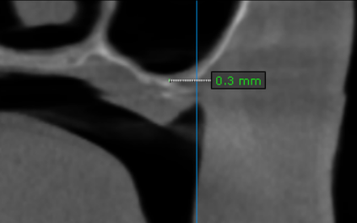
27 region | 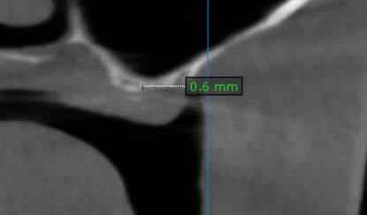
31 region | 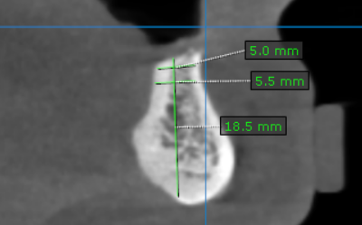
32 region | 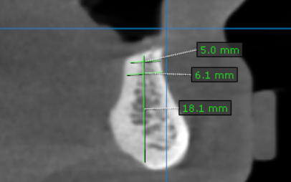
33 region | 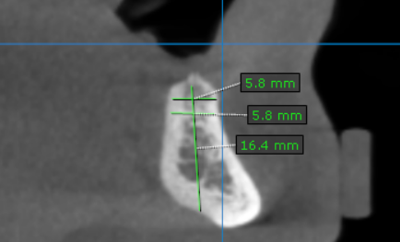
34 region | 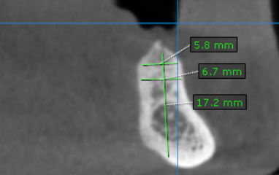
35 region | 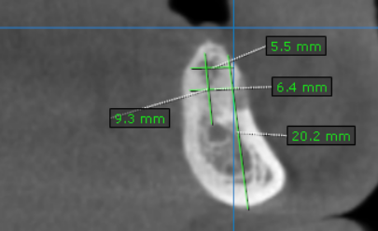
36 region | 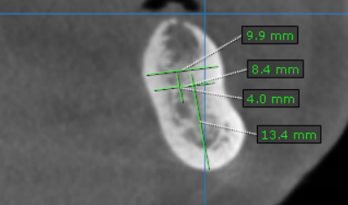
37 region | 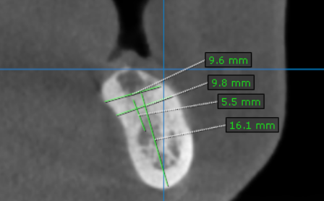
41 region | 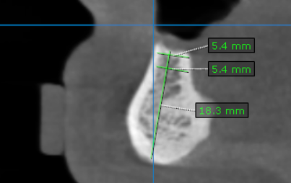
42 region | 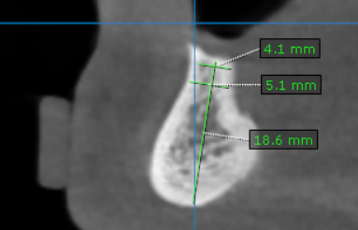
43 region | 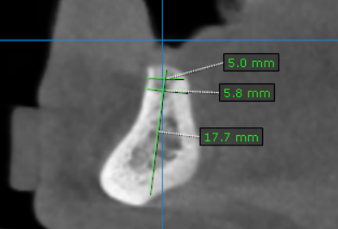
44 region | 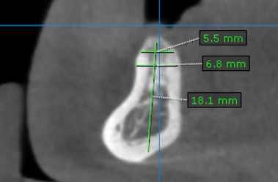
45 region | 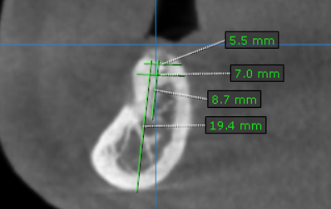
46 region | 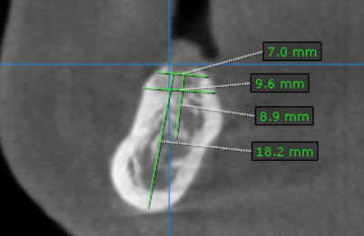
47 region | 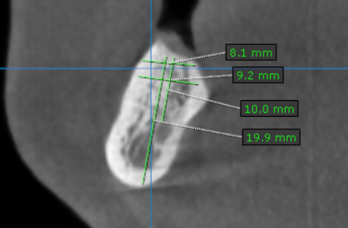

**** End of report ****

